Project 4 Option: Traffic model
Abstract
The purpose of this paper is to discover how simplest traffic CA model can be applied to traffic flow simulations. First, we introduce the two types of traffic model: car traffic model, car and bus traffic model. Second, to evaluate dynamic traffic flow, we developed a traffic flow simulator that uses simplest cellular automata model. The simulation was implemented in python programming language.

Introduction
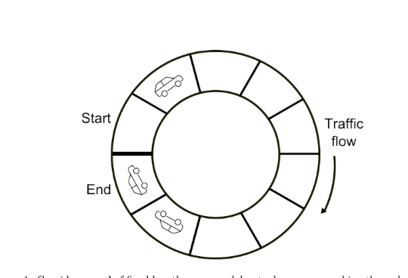
A cellular automaton (CA) is a collection of cells arranged in a grid of specified shape, such that each cell changes state as a function of time, according to a defined set of rules driven by the states of neighboring cells. CAs have been suggested for possible use in public key cryptography, as well as for applications in geography, anthropology, political science, sociology and physics, among others. The first application of the Cellular Automaton for simulation of traffic flows on streets and highways was introduced by Nagel and Schreckenberg (1992). The basic Cellular Automaton model from Nagel-Schreckenberg has been checked against measurements of realistic traffic flow on urban streets and motorways in Germany. There are some CA models have been quiet used, like Nagel-Schreckenberg model (1992) and BJH model (Benjamin, Johnson and Hui 1996). In the CA model, the street is divided into cells at a typical space which is the space occupied by vehicles in a dense jam. The space is depended by car length and distance to the preceding car. Each cell can be occupied at most one car or empty. In my model, I put buses in the cell and different from the car is that it need 2 space empty to move.
There are four steps movement in the simplest rule set, which leads to a realistic behavior.
Step 1: All the cars will move one step and all the buses will move 2 step.
Step 2: If the next step of car is empty then move and mark as 1 movement, if the next two steps of bus is empty then move and mark as 1 movement as well.
Step 3: The speed for that instant is the movement / total space.
Step 4: Do some iteration until the speed is constant.
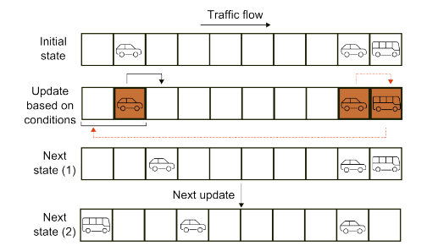

Algorithm Analysis and discussion
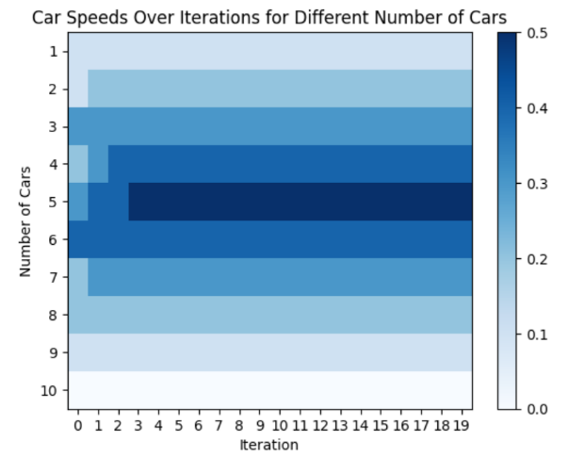
In the first part of the initialize the road, I use 0 and 1 to define empty or have car respectively. I first create a array full of zeros, then I use rng.choice and set replace = False ( So I can get number without repetition.). And use for loop to make those chosen position to be 1. The car model is simple, I only need the IF function to detect whether there is “0” of the space in front of it and checking whether it reach the end of the road. If it happens, it only needs to check the first space is “0” or not. .copy is also important, this makes the function more efficient. Then, I have drawn a plot using imshow. The graph uses shade of colors shows a trend increase from 0.1 to 0.5 then decrease to 0. When there are 5 cars, the speed is max which is 0.5. Each cars need a space in front of it, so that it can move instant, if we combine the space in front and the car itself. It is obviously that 10/2/10 = 0.5.

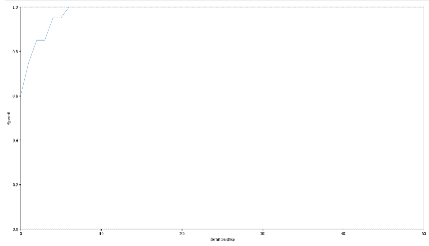
In the second part of the initialize the road, I use 0, 1 and 2 to define empty, car and bus respectively. I still create array full of zeros, then I do the same thing to choose cars and buses together. As the rng.choice’s output is an array either. I use this array to choose the buses’ position. When doing initialize, I set buses position first and use an if condition to justify the next position is 0 or not. If it is not 0, this means that position belong the bus, so we will skip it. For the bus and car model: I will first check whether the position is 2. And there are three cases to consider: First is at the boundary, second is one step away to the boundary and last is other places. After doing this category, the movement step is similar to car which one is next two should empty and other is next one should empty.
We suppose that Number of passengers per car is 5 and Number of passengers per bus is 30. Buses has 6 times capacity greater than car. And it only takes 1 more empty cell compare to cars. So hypothesis is that the more buses it have, the more speed we can have.
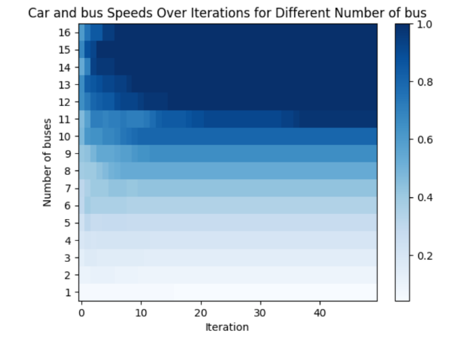
I first using 4 cars and 16 buses which is the maximum number of buses under the condition of 500 passengers. Next, I iterate from 16 buses to 0 bus. From using imshow, the graph tells me that the minimum buses to reach 0.9 speed is 11 buses. From the line graph that I draw, among different number of buses, they all share the same trend which the greater the number of buses are, the greater the speed are. Next, I try different seed from seed 1 to seed 15. The conclusion is that no matter the seed number are, the minimum number of buses are 11 and all the seed follow the same trend as I said above.

Conclusion
The graph of buses and cars shows the some result with my hypothesis. With the increase of the number of buses, the speed is increased.
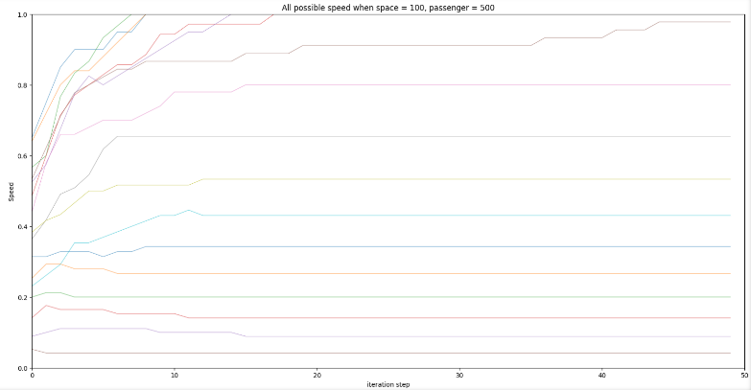

Reference
K. Nagel, M. Schreckenberg (1992). A cellular automaton model for freeway traffic, Journal de Physique I 2(12), 2221-2229.
Fukui M and Ishibashi Y (1996), J. Phys. Soc. Japan 65 1868.
D Ding(2015) Modeling and simulation of highway traffic using a cellular automaton approach.

